PENETRATION TESTING REPORT
FOOTPRINTING & NETWORK SCANNING PHASES

W2-PM-FINAL | CYBERSECURITY | WEEK 2

Pentester Name (Cybersecurity Professional) | Faizan shaikh
Program / Batch | B082-Networkwalks
Date | 11-11-2026
Modules Completed | W2-PM1 (Multiple Kali Tools)  W2-PM1 (Multiple Kali Tools)  W2-PM3 (Maltego based Footprinting Attacks)  W2-PM5 (Zenmap Scanning)
Client / Target | Authorized lab target  My own local LAN Network
Permission secured? | Yes – only authorized systems and networks
Phases Covered | Phase 1: Reconnaissance & Footprinting (Kali Tools, GHDB, Maltego, theHarvester)  Phase 2: Scanning & Network Discovery (Zenmap)

1. Liability Disclaimer
All activities in this report are for education and authorized security testing only. Testing must be limited to systems owned by me or covered by written permission. Unauthorized scanning or access may violate laws and organizational policies. The student is responsible for following the approved scope and applicable rules.

2. Introduction
This report describes the Week 2 practical activities completed using Kali Linux tools, TheHarvester, and Zenmap. The work covers footprinting a permitted domain and discovering hosts on an authorized local lab network. The purpose is to understand what information is publicly visible and how network devices can be identified during a basic security assessment.
The report records the tools used, the steps followed, observations, possible risks, and recommended security improvements. Exact IP addresses, domain details, and scan findings should be copied from the student's own terminal output.

3. Tools Used
Tool | Purpose
Kali Linux | Operating system used to run the footprinting utilities.
WHOIS | Checks public domain registration details and name-server information.
WhatWeb | Identifies website technologies that are visible from the web response.
nslookup | Queries DNS to find the IP address or DNS records for a domain.
curl | Sends a web request and displays response information; -I requests headers only.
Wafw00f | Checks whether a website appears to use a Web Application Firewall (WAF).
DNSRecon | Collects and reviews publicly available DNS record information.
TheHarvester | Collects public domain-related information from supported data sources.
Maltego | Displays information and relationships in a visual link-analysis graph.
Zenmap | Graphical interface for Nmap used to discover hosts and review scan results.

4. Activities Performed

4.1 Footprinting with Multiple Kali Tools (W2-PM1)
I used Kali Linux tools to collect different types of publicly available information about the selected authorized domain. Each tool provides a different view of the target.
- WHOIS: Checked public domain registration details, such as registrar and name servers.
- WhatWeb: Checked which web technologies could be identified from the website.
- nslookup: Queried DNS to see how the domain name resolves.
- curl: Requested website response information and reviewed the HTTP headers.
- Wafw00f: Checked whether a Web Application Firewall could be detected.
- DNSRecon: Reviewed DNS records such as name-server and mail-related records.
- Maltego: Used a visual graph to organize entities and relationships from available information.
Observation: The screenshots show these utilities being opened and used in Kali Linux. The actual domain, records, detected technologies, and responses should be reported exactly as displayed in the student's own output.

4.2 Maltego-Based Footprinting (Completed)
I also completed a footprinting exercise using Maltego. Maltego is a visual link-analysis tool that displays information as entities and connections in a graph.
I opened Maltego, created or viewed a graph, and used the available information to observe how related entities can be connected. This helped me understand how visual relationship mapping can support reconnaissance.
Observation: The supplied screenshot shows the Maltego interface with a graph and related information. Add the full-size screenshot below as evidence. The exact entities and relationships should match the graph from your own practical.
[ INSERT SCREENSHOT: MALTEGO GRAPH ]
Paste the screenshot showing your completed Maltego graph.

4.3 TheHarvester-Based Footprinting (W2-PM4)
I ran TheHarvester in Kali Linux to gather publicly available information associated with the selected authorized domain. The tool uses supported public sources and may return items such as email addresses, hostnames, and subdomain information.
Observation: The supplied screenshots show TheHarvester running in the terminal and displaying its output. The results depend on the selected source and available public data. Any collected information should be checked before treating it as accurate.

4.4 Network Scanning with Zenmap (W2-PM5)
I used Zenmap, the graphical interface for Nmap, to view network discovery results in the authorized lab. Zenmap can show responding hosts and, depending on the scan, port and service information. Its topology view helps display discovered hosts visually.
- Opened Zenmap and entered the authorized lab IP address or network range.
- Selected the scan profile used for the exercise and started the scan.
- Reviewed the hosts and scan information returned by Zenmap.
- Opened the topology view to see the discovered network devices.
Observation: The supplied screenshots include Zenmap's topology view and scan-results window. Enter the actual target range, number of hosts, and detected results from your own scan below.
Authorized target / subnet | 10.34.170.0/24
Scan profile | Quick Scan
Live hosts found | 2 live hosts (10.34.170.40, 10.34.170.215)
Ports / services observed | 10.34.170.40: 21 (FTP), 80 (HTTP), 135 (MSRPC), 139 (NetBIOS-SSN), 445 (Microsoft-DS), 5432 (PostgreSQL), 8000 (HTTP-ALT). 10.34.170.215: 53 (Domain/DNS).

5. Risk Analysis / Impact
The following are possible security concerns associated with the types of information collected. They are observations for review, not confirmed vulnerabilities.
Finding | Evidence / Observation | Potential Impact | Indicative Level
Technology details visible | WhatWeb may identify website technologies. | Could help an attacker choose what to research further. | Low–Medium
Domain / DNS information visible | WHOIS and DNSRecon may reveal public domain records. | Could help map the organization's public infrastructure. | Low–Medium
HTTP response details visible | curl may display headers and response details. | May expose unnecessary technical information. | Low
WAF information detectable | Wafw00f may identify a WAF product or indicate its presence. | May reveal part of the web security setup. | Low
Public domain-related information | TheHarvester may return public emails or hostnames. | Could make public exposure easier to understand and review. | Low–Medium
Devices visible on the LAN | Zenmap may identify responding hosts on the scanned network. | Unknown devices should be checked by the network owner. | Medium
Risk note: A detected technology, IP address, DNS record, WAF, or live host does not by itself prove a vulnerability. Further authorized validation would be needed.

6. Recommendations
- Review public technology information: Check which software and versions are visible from outside.
- Update website software: Keep the CMS, plugins, and server software patched.
- Review HTTP headers: Avoid exposing unnecessary technical details in web responses.
- Check DNS records: Remove outdated records and publish only required services.
- Maintain WAF protection: Keep the WAF properly configured, updated, and monitored.
- Review public information: Check whether exposed contact or domain information is appropriate to publish.
- Monitor the local network: Perform approved periodic discovery to maintain an accurate device inventory.
- Investigate unknown devices: Confirm whether unexpected devices are authorized.
- Document network changes: Keep IP, device, and topology records up to date.

7. Conclusion
During Week 2, I practised footprinting and network discovery using Kali Linux tools, TheHarvester, and Zenmap. I learned that WHOIS and DNS tools provide domain information, curl checks web responses, WhatWeb and Wafw00f review visible website details, and Maltego helps organize relationships. TheHarvester demonstrates collection of public domain-related information, while Zenmap presents network discovery results.
These activities helped me understand the early stages of a security assessment and the importance of recording evidence, checking results, and working only within an authorized scope.

8. Evidences Collected
The image below is the overview of the practical screenshots supplied for this report. For a final submission, add the original full-size screenshots under the matching tool headings so commands and results can be read clearly.

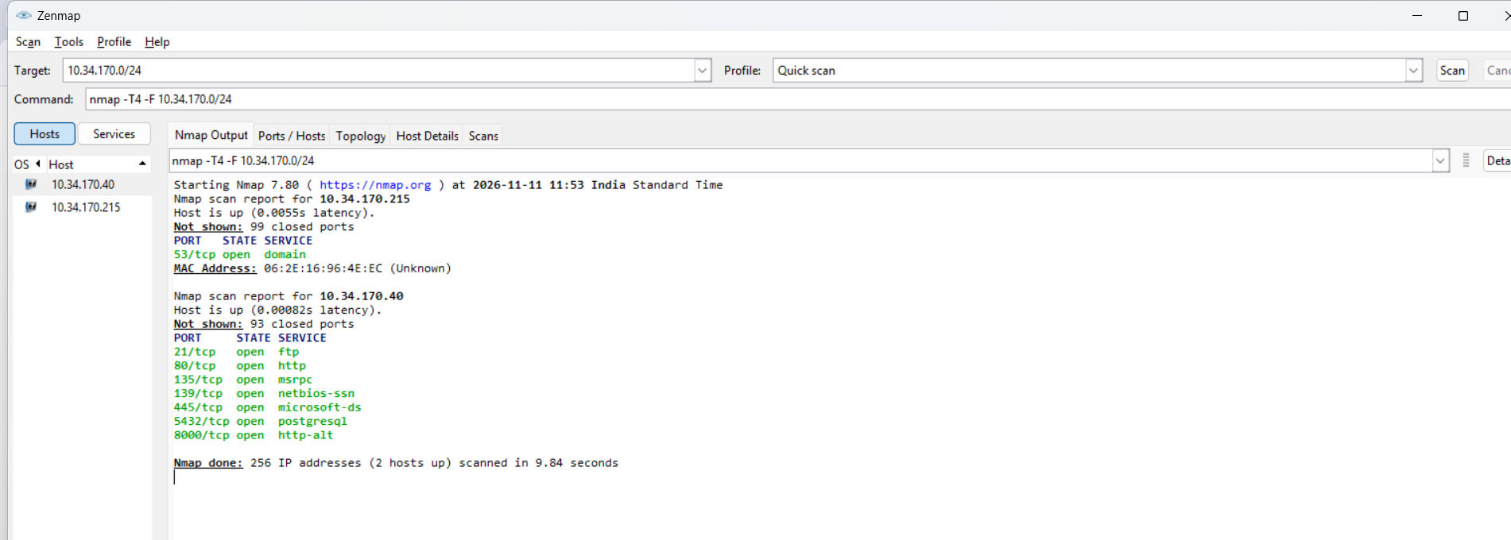

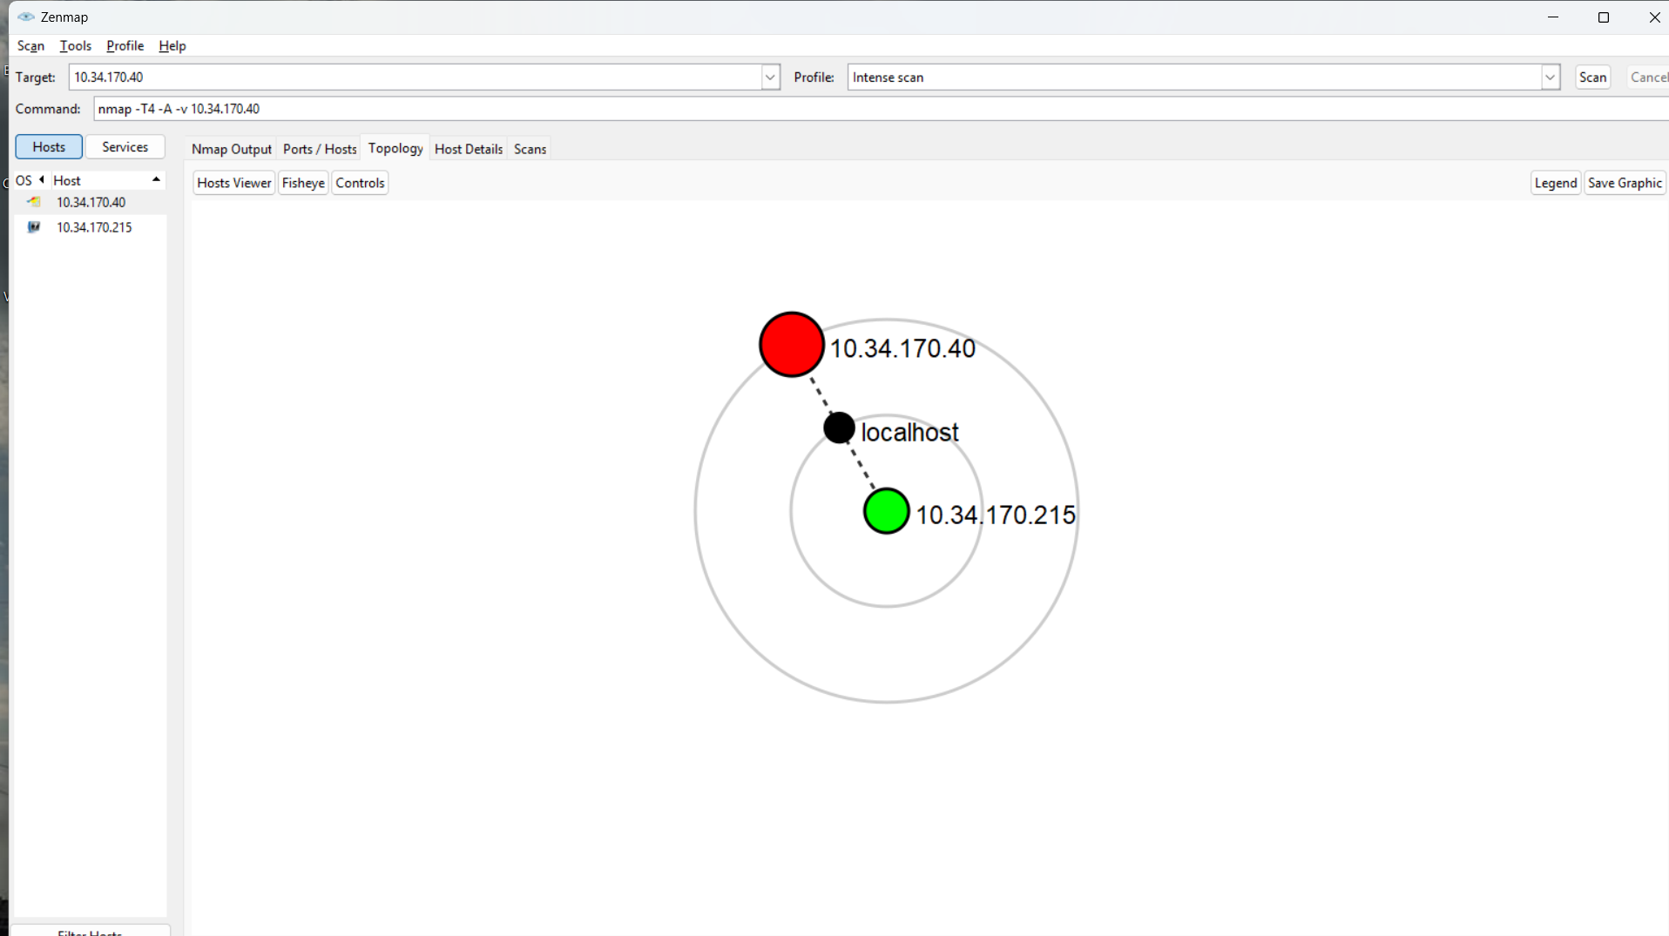

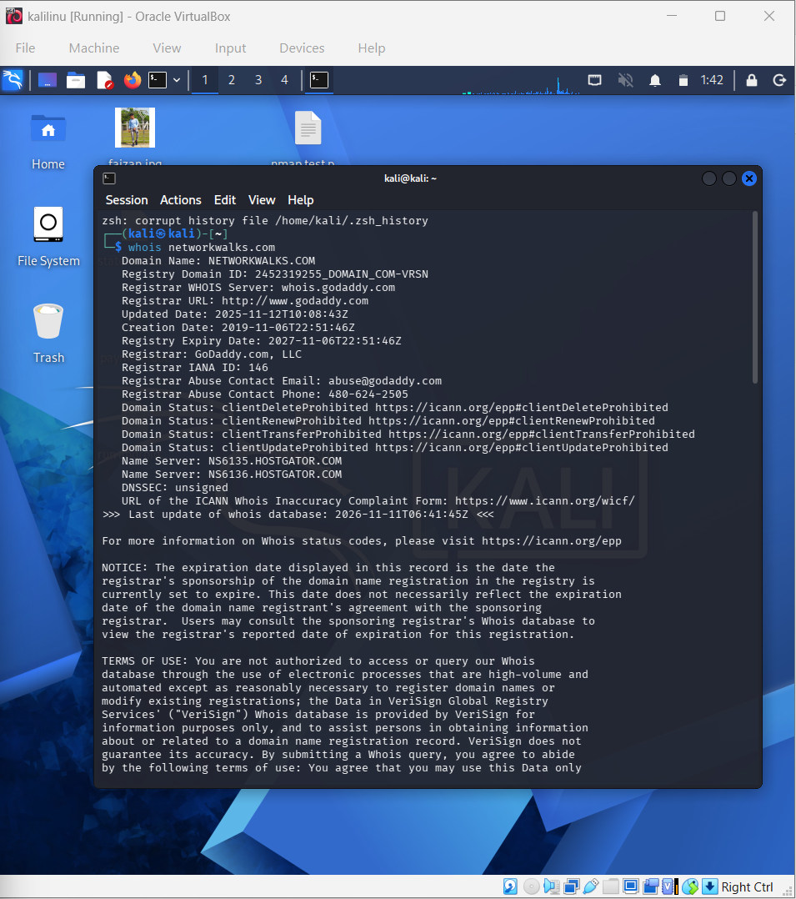

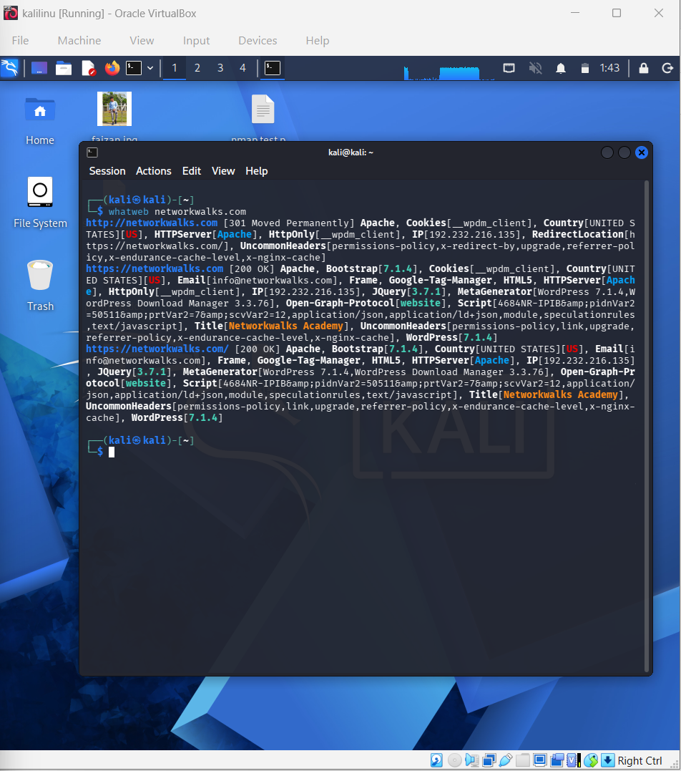

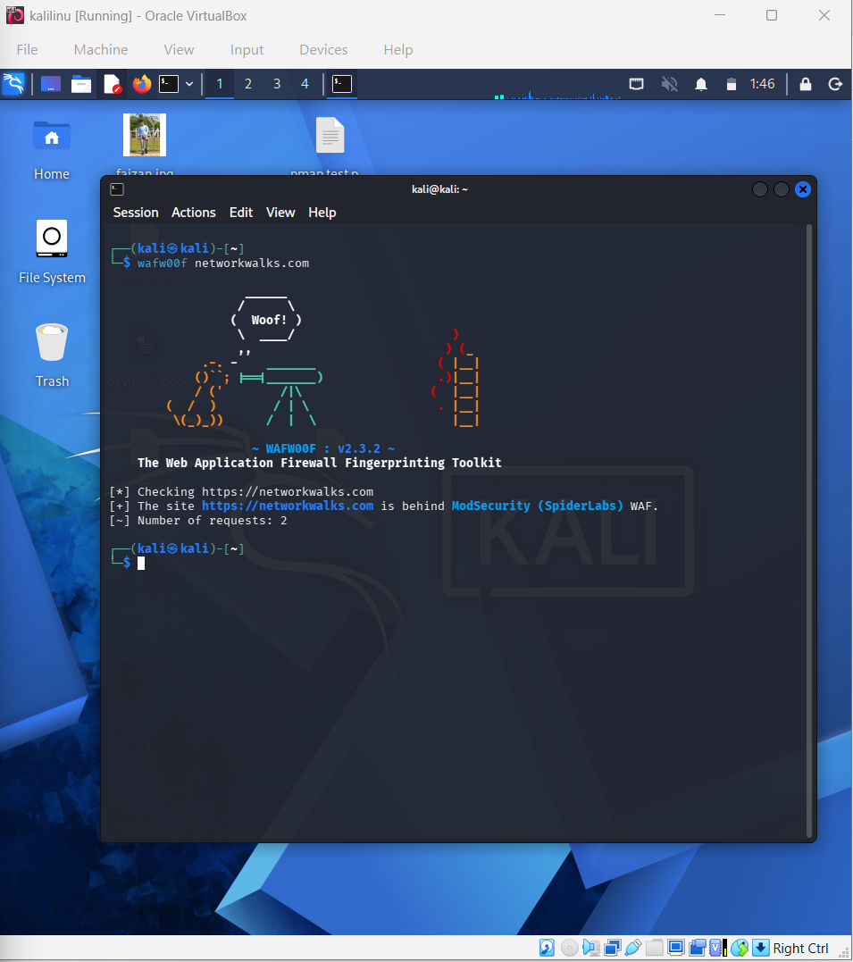

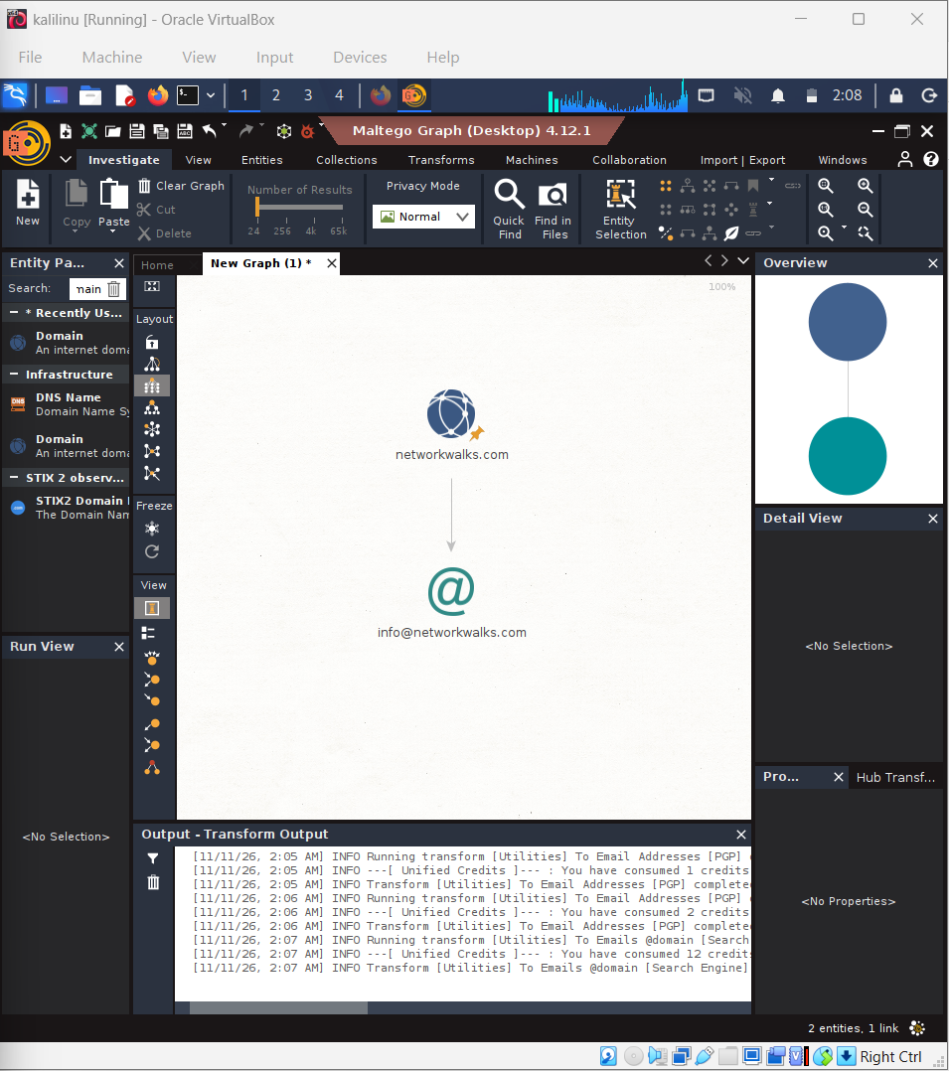

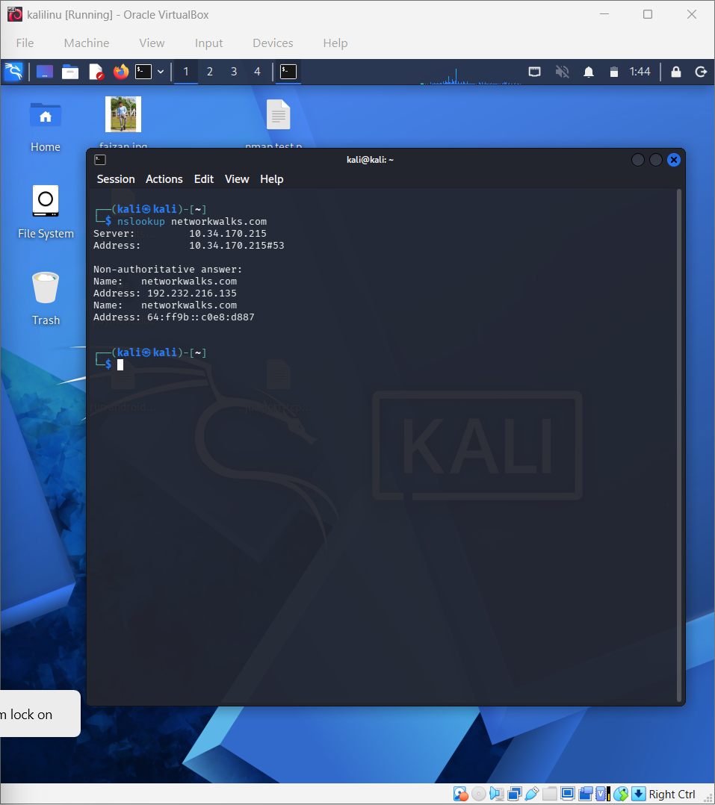

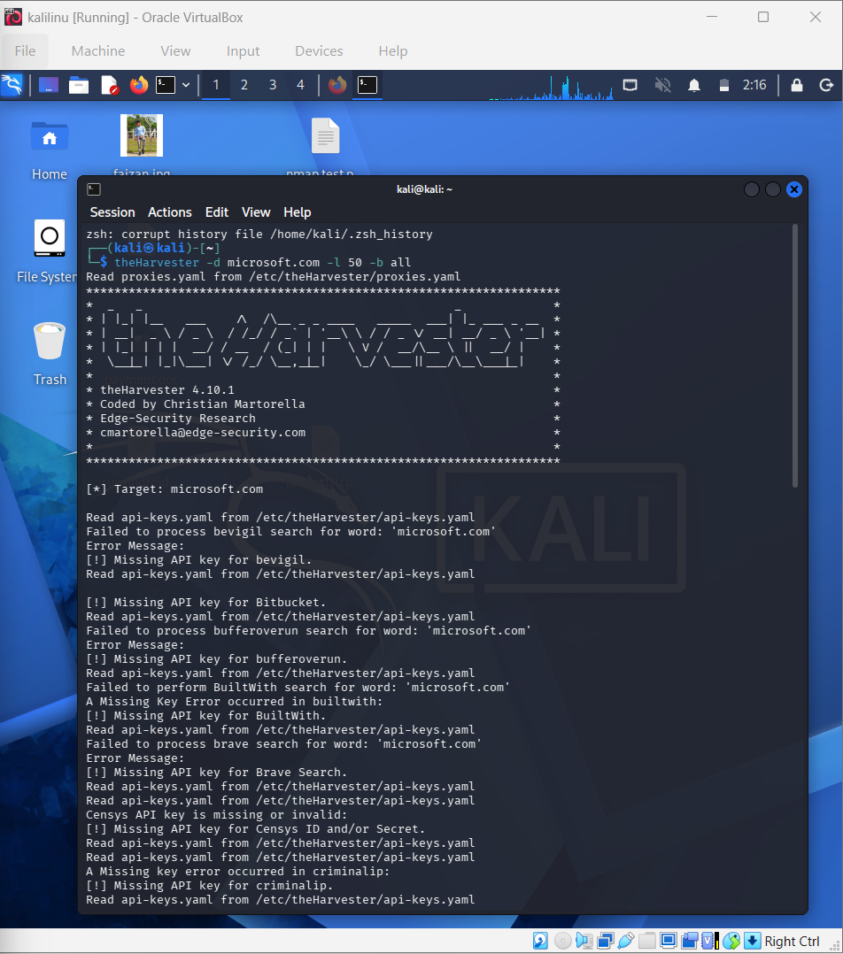

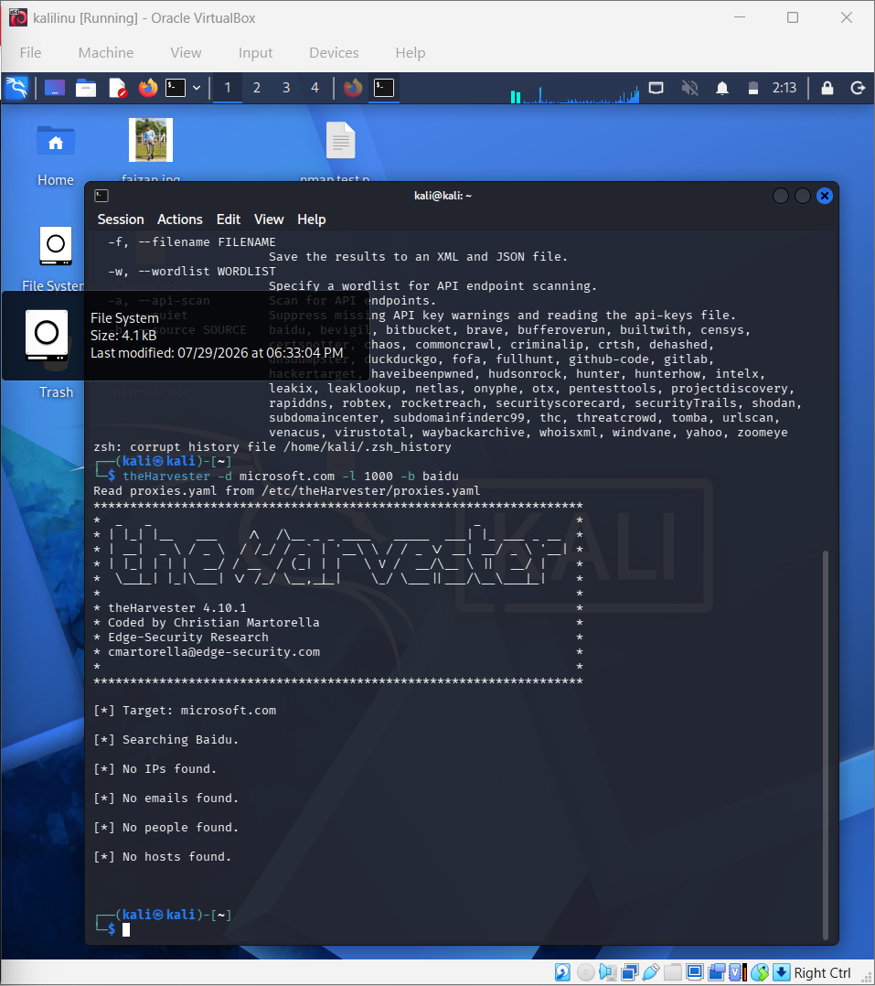

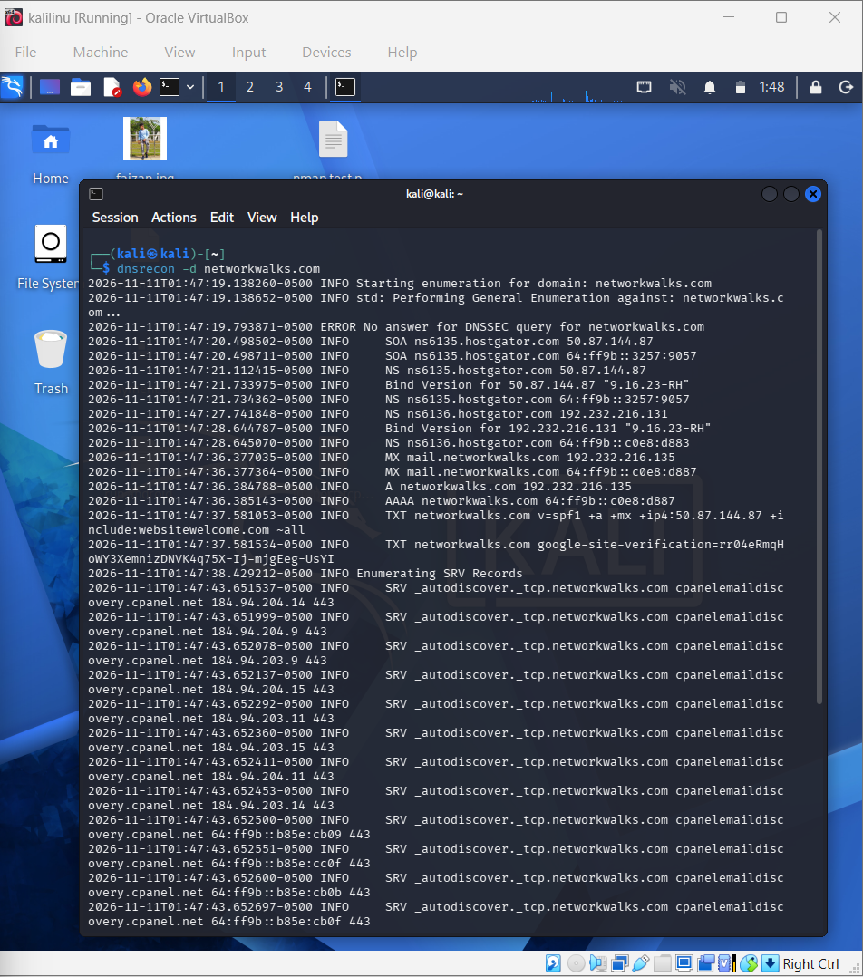

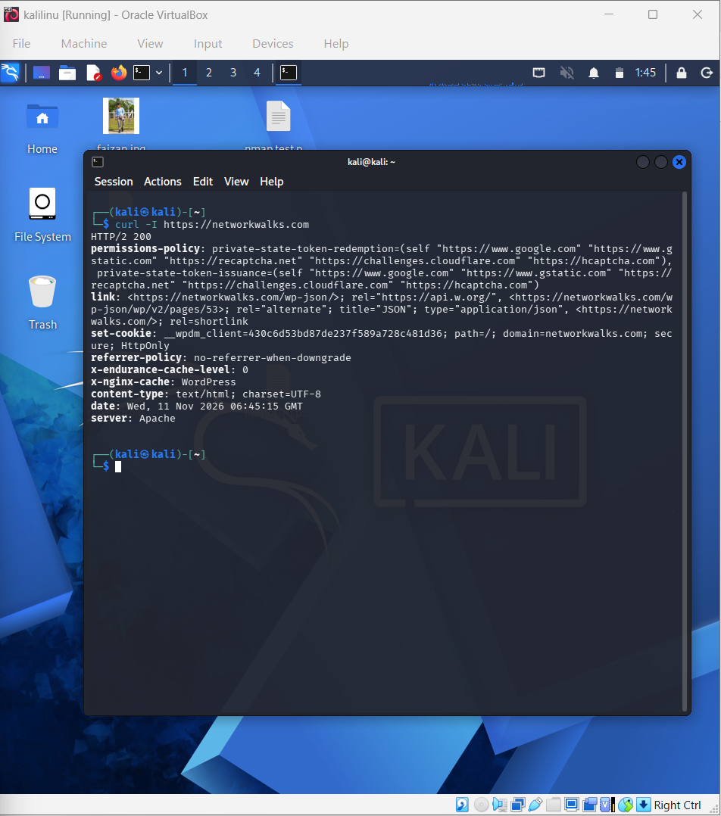

👤 Author
Faizan Shaikh
Cybersecurity Professional B082
LinkedIn: www.linkedin.com/in/faizan-shaikh-099803378

📌 Project Information
Program Name: Cybersecurity program at Networkwalks | Week: 02
Repository: GitHub :- https://github.com/faizsk1892-lang/Cyber-security-network-lab2

